Chapter 29-2

doubly linked lists

Problems with Singly linked list

Can we insertBefore?

public static <T> Node<T> insertBefore (Node<T> p, T item)

Can we remove?
public static <T> Node<T> remove(Node<T> p)

Can we insertLast?
public static <T> Node<T> insertLast(Node<T> front, T item)

Doubly circular linked list with a dummy header

header
null
data
data
data

- An empty list looks like:
header
null

Class DNode

//Example 29-2-1
//DNode.java
public class DNode<T>
{
public T value;
public DNode<T> prev;
public DNode<T> next;
public DNode()
{
value = null;
prev = this;
next = this;
}
public DNode(T item)
{
value = item;
prev = this;
next = this;
}
}

Build a doubly linked list

//Example 29-2-2
public class Demo
{
public static void main(String[] args)
{
DNode<String> header, n1, n2; //line 7
header =new DNode<String>(); //line 8
n1=new DNode<String>("Peter"); //line 9
n2=new DNode<String>("Paul"); //line 10
header.next= n1; //line 11
n1.next= n2; //line 12
n2.next= header; //line 13
header.prev= n2; //line 14
n2.prev = n1; //line 15
n1.prev = header; //line 16
}
}

Process a doubly linked list

//Example 29-2-3
public class Demo
{
public static void main(String[] args)
{
DNode<String> header; //line 7
header =new DNode<String>(); //line 8
header.next=new DNode<String>("Peter"); //line 9
header.next.next=new DNode<String>("Paul"); //line 10
header.next.next.next= header; //line 11
header.prev= header.next.next; //line 12
header.next.next.prev = header.next; //line 13
header.next.prev = header; //line 14
System.out.println("Front to back:");
DNode<String> p= header.next;
while (p!=header)
{
System.out.println(p.value);
p=p.next;
}
System.out.println("Back to front:");
p= header.prev;
while (p!=header)
{
System.out.println(p.value);
p=p.prev;
}
}
}
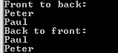

toString and seqSearch

//Example 29-2-4
public class DoublyLinkedList<T>
{
//Pre: header points to the header node of a circular doubly-linked list
//Return: "null" if list is empty; "[data1, data2, …]" otherwise
public static <T> String toString(DNode<T> header)
{
if (header.next == header) return "null";

DNode<T> p = header.next;
String s = "[" + p.value;
while (p.next != header)
{
p = p.next;
s += ", " + p.value;
}
s += "]";
return s;
}
//Pre: header points to the header node of a circular doubly-linked list
//Return: null if key not in list; the node in list that matches key otherwise
public static <T> DNode<T> seqSearch (DNode<T> header, T key)
{
DNode<T> p=header.next;
while (p!=header)
{
if (p.value.equals(key)) return p;
p=p.next;
}
return null;
}
}

//Example 29-2-5
import java.util.Scanner;
public class Demo
{
public static void main(String[] args)
{
Scanner f=new Scanner(System.in);
DNode<String> header;
header =new DNode<String>();
header.next=new DNode<String>("Peter");
header.next.next=new DNode<String>("Paul");
header.next.next.next= header;
header.prev= header.next.next;
header.next.next.prev = header.next;
header.next.prev = header;
System.out.println(DoublyLinkedList.toString(header));
System.out.print("Enter key:");
String s=f.nextLine();
DNode<String> result= DoublyLinkedList.seqSearch(header, s);
if (result==null) System.out.println(s+" not in list");
else System.out.println(result.value+" in list");
}
}
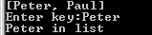

Build a doubly linked list dynamically

//Example 29-2-6
import java.util.Scanner;
public class DoublyLinkedList<T>
{
…
//Pre: A sequence of lines entered via keyboard; -oo- is sentinel
//Return:A circular doubly linked list with a dummy header of the input lines in reverse, 1 line per
// node
public static DNode<String> buildReverseList()
{
Scanner input = new Scanner(System.in);
DNode<String> header = new DNode<String>(), node = null;
String line = null;
while (true)
{
line = input.nextLine();
if (line.equals("-oo-")) break;
node = new DNode<String>(s);
node.prev = header;
node.next = header.next;
header.next.prev = node;
header.next = node;
}
return header;
}
}

//Example 29-2-7
public class Demo
{
public static void main(String[] args)
{
DNode<String> header = DoublyLinkedList.buildReverseList();
System.out.println(DoublyLinkedList.toString(header));
}
}
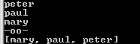

//Example 29-2-8
public class DoublyLinkedList<T>
{
…
//Pre: A sequence of lines entered via keyboard; -oo- is sentinel
//Return:A circular doubly linked list with a dummy header of the input lines, 1 line per node
public static DNode<String> buildList()
{
Scanner input = new Scanner(System.in);
DNode<String> header=new DNode<String>(), node = null;
String line = null;
while (true)
{
line = input.nextLine();
if (line.equals("-oo-")) break;
node = new DNode<String>(s);
node.next = header;
node.prev = header.prev;
header.prev.next = node;
header.prev = node;
}
return header;
}
}

//Example 29-2-9
public class Demo
{
public static void main(String[] args)
{
DNode<String> header = DoublyLinkedList.buildList();
System.out.println(DoublyLinkedList.toString(header));
}
}
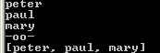

insertAfter and insertBefore

//Example 29-2-10
public class DoublyLinkedList<T>
{
…
//Post: item inserted after the node referenced by p
//Return:The new node inserted
public static <T> DNode<T> insertAfter(DNode<T> p, T item)
{
DNode<T> newNode=new DNode<T>(item);

newNode.next = p.next;
newNode.prev = p;
p.next.prev = newNode;
p.next = newNode;

return newNode;
}
//Post: item inserted before the node referenced by p
//Return:The new node inserted
public static <T> DNode<T> insertBefore(DNode<T> p, T item)
{
DNode<T> newNode=new DNode<T>(item);

newNode.next = p;
newNode.prev = p.prev;
p.prev.next = newNode;
p.prev = newNode;

return newNode;
}
}

//Example 29-2-11
import java.util.Scanner;
public class Demo
{
public static void main(String[] args)
{
Scanner f=new Scanner(System.in);
DNode<String> header= DoublyLinkedList.buildList();
System.out.print("Insert what?");
String item =f.nextLine();
System.out.print("After what?");
String after=f.nextLine();
DNode<String> result= DoublyLinkedList.seqSearch(header, after);
if (result==null) System.out.println(after+" not in list. Insert failed.");
else
{
DoublyLinkedList.insertAfter(result, item);
System.out.println(item+" inserted after "+after);
}
System.out.println(DoublyLinkedList.toString(header));
System.out.print("Insert what?");
item =f.nextLine();
System.out.print("Before what?");
String before=f.nextLine();
result= DoublyLinkedList.seqSearch(header, before);
if (result==null) System.out.println(before +" not in list. Insert failed.");
else
{
DoublyLinkedList.insertBefore(result, item);
System.out.println(item+" inserted before "+ before);
}
System.out.println(DoublyLinkedList.toString(header));
}
}
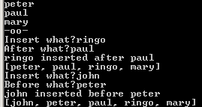

Remove a particular element

//Example 29-2-12
public class DoublyLinkedList<T>
{
…
//Pre: p points to a data node in this DoublyLinkedList
//Post: node p removed from list
public static <T> void remove(DNode<T> p)
{
p.prev.next = p.next;
p.next.prev = p.prev;
}
}
//Example 29-2-13
import java.util.Scanner;
public class Demo
{
public static void main(String[] args)
{
Scanner f=new Scanner(System.in);
DNode<String> header=DoublyLinkedList.buildList();
System.out.println(DoublyLinkedList.toString(header));
System.out.print("Delete what?");
String item =f.nextLine();
DNode<String> result= DoublyLinkedList.seqSearch(header, item);
if (result != null) DoublyLinkedList.remove(result);
System.out.println(DoublyLinkedList.toString(header));
}
}
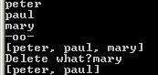

Word jumble

//Example 29-2-14
import java.util.Scanner;
import java.util.Random;
public class Demo
{
//Desc: Jumble the letters in a word.
public static void main(String[] args)
{
Scanner f=new Scanner(System.in);

System.out.print("Word: ");
String word = f.nextLine();

String jumbleword = jumbleLetters(word);
System.out.println("Jumbled Word: " + jumbleword);
}
public static String jumbleLetters(String word)
{
Random generator = new Random();
DNode<Character> header = new DNode<Character>();
String jumbleWord = "";

for (int i = 0; i < word.length(); i++)
if (generator.nextInt(2) == 0)
DoublyLinkedList.insertBefore(header.next, word.charAt(i));
else DoublyLinkedList.insertAfter(header.next, word.charAt(i));

while (header.next != header)
{
jumbleWord += header.next.value;
DoublyLinkedList.remove(header.next);
}

return jumbleWord;
}
}

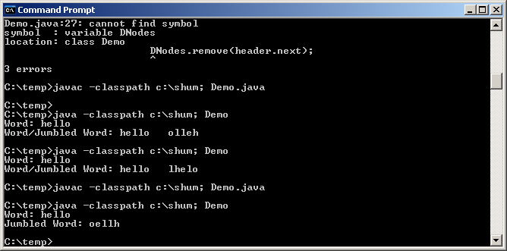

Case study -- The Josephus problem

//Example 29-2-15
import java.util.Random;
import java.util.Scanner;
public class Demo
{
//Desc: A professor selects 1 from n students for a 5 extra-point bonus. The professor places the
// students in a circle and then draws a number m (1<=m<=n) from a hat. The game is
// played by having the professor walk clockwise around a circle, stopping at every mth
// student, whom is asked to leave the game. The professor continues to walk clockwise,
// asking every mth student to leave the game. The last person in the game is the winner.
//Input: The number of students followed by names of students one on each line entered via the
// keyboard
//Output:The random number m, and the winner of the game
public static void main(String[] args)
{
Random generator = new Random();
Scanner input = new Scanner(System.in);

System.out.println("Enter number of students: ");
int totalStudents = input.nextInt();

System.out.println("Enter names of " + totalStudents +
" students, one on each line, -oo- to end: ");
DNode<String> header=DoublyLinkedList.buildList();
System.out.println("One of you will get 5 extra points.");
int randomNum = generator.nextInt(totalStudents)+1;
System.out.println("Generating random number ....." +randomNum);

josephus(header, totalStudents, randomNum);
}
//Desc: A loop moves around the list of n elements circularly and erases every mth students until
// only 1 remains.
//Pre: header points to the list; n is length of list; m is a random number
//Output:The list is printed each time a student is removed.
// The winner is printed at the end
public static void josephus(DNode<String> header, int totalStudents, int randomNum)
{
DNode<String> curr = header.next;
System.out.println(DoublyLinkedList.toString(header));
for (int i=1; i < totalStudents; i++)
{
for (int j = 1; j < randomNum - 1; j++)
{
if (curr.next == header) curr = curr.next;
curr = curr.next;
}
System.out.print("Delete " + curr.value);
if (curr.next == header) curr = curr.next;// is this needed if it's the first in the for?
curr = curr.next;
DoublyLinkedList.remove(curr.prev);
System.out.println(DoublyLinkedList.toString(header));
}
System.out.println("Student " + curr.value + " wins the bonus");
}
}
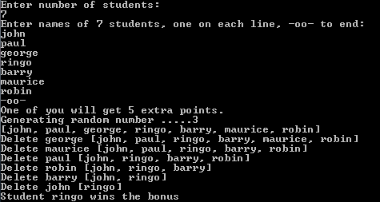

Programming Exercise

Part I

Among all the DoublyLinkedList methods we discussed in class, all except buildList and buildReverseList are parameterized. Modify class DoublyLinkedList to exclude these 2 non-parameterized methods. Instead, write parameterized methods insertFirst, insertLast, removeFirst, removeLast for the DoublyLinkedList class. Also, you need to write the size method.

Hint:
- Complete the following class DoublyLinkedList<T> (please include documentation for the first 5 methods).
- Note that methods insertFirst, insertLast, removeFirst, removeLast return nothing, since header never changes. Do not reinvent the wheel. Use existing methods to implement these 4 methods.
public class DoublyLinkedList<T>
{
public static <T> String toString(DNode<T> header)
{
//given
}
public static <T> DNode<T> seqSearch (DNode<T> header, T key)
{
//given
}
public static <T> DNode<T> insertAfter(DNode<T> p, T item)
{
//given
}
public static <T> DNode<T> insertBefore(DNode<T> p, T item)
{
//given
}
public static <T> void remove(DNode<T> p)
{
//given
}
//Pre: header points to the header node of a circular doubly-linked list
//Return: The number of data nodes in the list
public static <T> int size(DNode<T> header)
{
//you will write
}
//Pre: list referenced by header cannot be empty
//Post: First element removed from list.
public static <T> void removeFirst(DNode <T> header)
{
//you will write
}
//Pre: list referenced by header cannot be empty
//Post: Last element removed from list.
public static <T> void removeLast (DNode <T> header)
{
//you will write
}
//Post: item inserted as first element of list.
public static <T> void insertFirst (DNode <T> header, T item)
{
//you will write
}
//Post: item inserted as last element of list.
public static <T> void insertLast (DNode <T> header, T item)
{
//you will write
}
}

Hand in/email:
- DoublyLinkedList.java

Part II

Modify the Josephus program to use the newly created class DoublyLinkedList. Since there is now a size method, the program should not ask the user for the number of students.

Hint:
- Write method buildList in class Demo:
//Pre: A sequence of names entered via keyboard, one on each line; -oo- is sentinel
//Return:A linked list of the names
public static DNode<String> buildList()
{
//read names and call DoublyLinkedList.insertLast and return the list
}

Hand in/email:
- Demo.java

